Supporting information 7: Validation of dPCR assays
To validate that the primers designed for the dPCR assays properly amplify at 60 °C, an additional gradient PCR was performed with each of the DNA pools (Supporting information 2). Gradient PCR was performed with the same 10 µL assays used for single specimen barcoding but with cycling conditions identical to the dPCR measurements and with the specific dPCR primers for each pool: 10 min at 96 °C for initial denaturation followed by 40 cycles of denaturation for 15 s at 98 °C and 30 s of annealing and extension at the respective gradient temperature. The temperature gradient levels ranged from 58.1 °C to 66 °C. PCR success was controlled on a 1% agarose gel. For all five taxa, a single band of the expected size was obtained at 59.8 °C and 60.6 °C, confirming that the dPCR assays amplify at the annealing temperature of 60 °C used in the dPCR measurements (Figure 7.1).
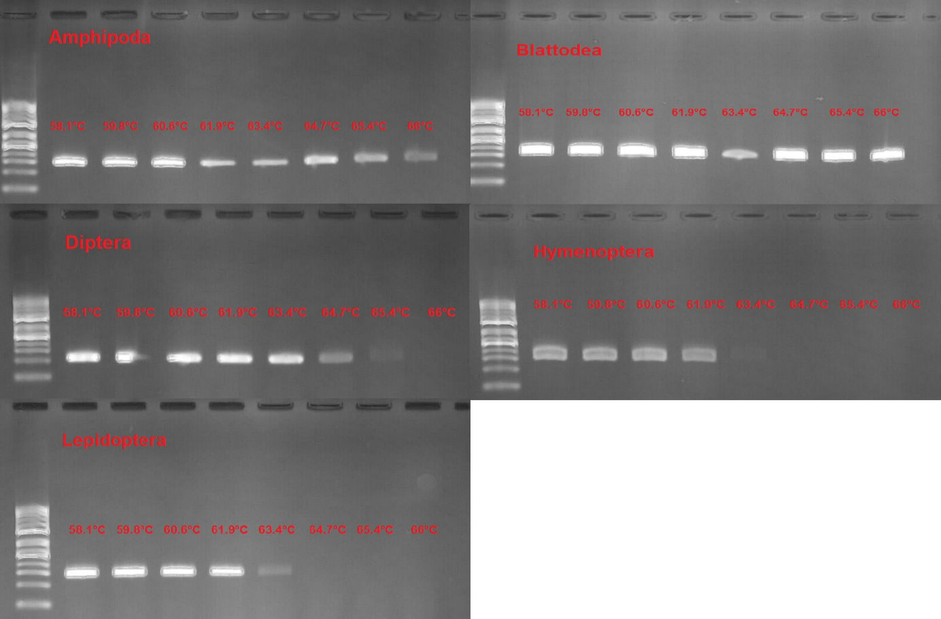
Figure 7.1: Gradient PCR of the dPCR assays on pooled DNA of the five target taxa. Agarose gel electrophoresis (1% agarose) of the products of gradient PCRs with the taxon-specific dPCR primers (Supporting information 4) on the DNA pool of each taxon (Amphipoda, Blattodea, Diptera, Hymenoptera, Lepidoptera). Each panel shows one taxon; lanes correspond to annealing/extension temperatures from 58.1 °C to 66 °C (58.1, 59.8, 60.6, 61.9, 63.4, 64.7, 65.4, 66 °C). The annealing temperature of the dPCR measurements (60 °C) lies between the 59.8 °C and 60.6 °C lanes. The DNA ladder ranges from 50 bp to 1000 bp. Expected amplicon sizes are given in Supporting information 4.

